Homonymic Rhyme

🔁 What is Homonymic Rhyme
# Source: AI Source: Provided by: [Data Path: Persons Table -> ID Column: 1, Name_En Column: Motasem Essam] -> From: [Chatgpt (GPT-4-turbo)] on [8/2/2025]
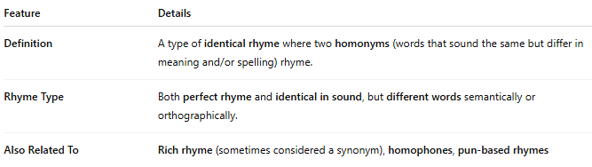
Feature | Details
Definition | A type of identical rhyme where two homonyms (words that sound the same but differ in meaning and/or spelling) rhyme.
Rhyme Type | Both perfect rhyme and identical in sound, but different words semantically or orthographically.
Also Related To | Rich rhyme (sometimes considered a synonym), homophones, pun-based rhymes

📝 Examples:
# Source: AI Source: Provided by: [Data Path: Persons Table -> ID Column: 1, Name_En Column: Motasem Essam] -> From: [Chatgpt (GPT-4-turbo)] on [8/2/2025]
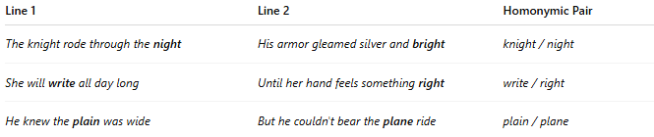
Line 1 | Line 2 | Homonymic Pair
The knight rode through the night | His armor gleamed silver and bright | knight / night
She will write all day long | Until her hand feels something right | write / right
He knew the plain was wide | But he couldn't bear the plane ride | plain / plane

🎭 Effect in Poetry:
# Source: AI Source: Provided by: [Data Path: Persons Table -> ID Column: 1, Name_En Column: Motasem Essam] -> From: [Chatgpt (GPT-4-turbo)] on [8/2/2025]
- Adds cleverness, playfulness, or ambiguity
- Useful in puns, riddles, lyrical wordplay, or double meanings
- Can enhance themes of duality, confusion, or irony

✅ When to Use:
# Source: AI Source: Provided by: [Data Path: Persons Table -> ID Column: 1, Name_En Column: Motasem Essam] -> From: [Chatgpt (GPT-4-turbo)] on [8/2/2025]
- In poems where sound and semantic tension matter
- When you want a rhyme to carry two meanings at once
- Often used in rap, satirical poetry, and riddles

